4.Git-HOL

Create a new branch GitWork and switch to it
- git checkout -b GitWork
Add a file hello.xml and update its content
- echo "<message>Hello from GitWork branch</message>" > hello.xml
Stage and commit the file
- git add hello.xml
- git commit -m "Added hello.xml from GitWork branch"
Switch back to master
- git checkout master
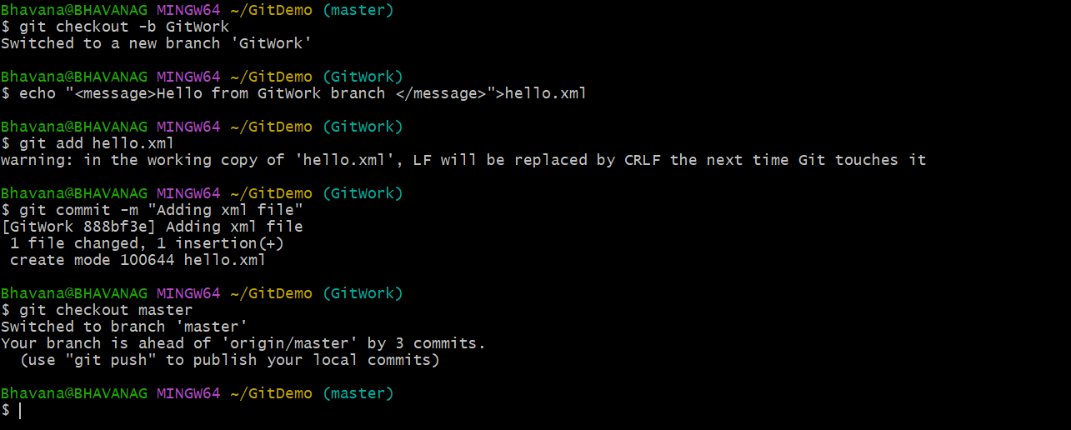

Add a different version of hello.xml in master
- echo "<message>Hello from master branch</message>" > hello.xml
Commit changes in master
- git add hello.xml
- git commit -m "Added hello.xml from master branch"
View logs in graph format
- git log --oneline --graph --decorate –all

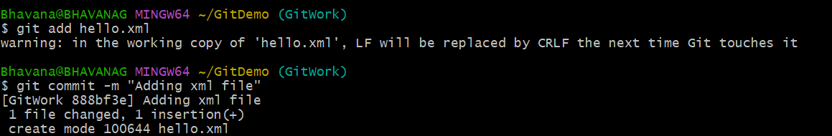
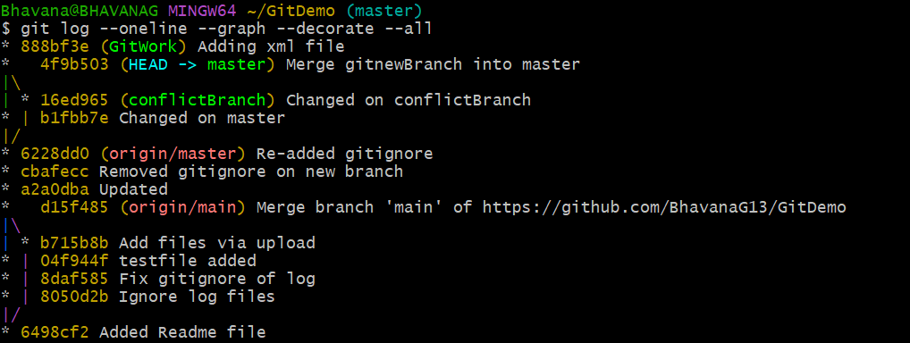
Check differences using CLI tool
- git diff master GitWork

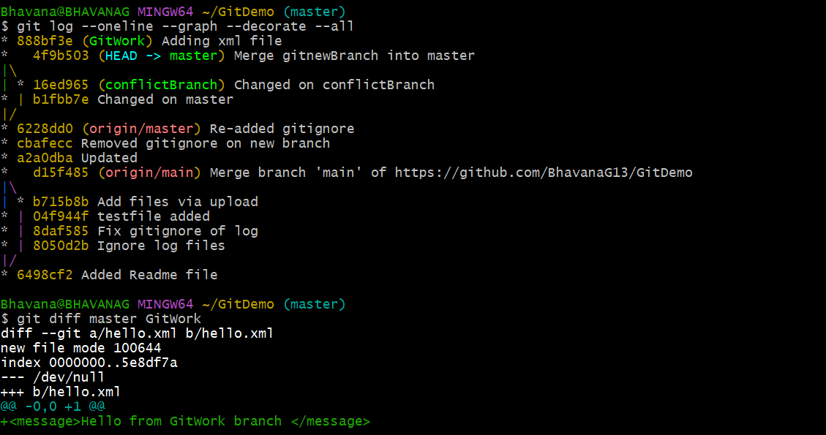
Merge GitWork into master
- git merge GitWork

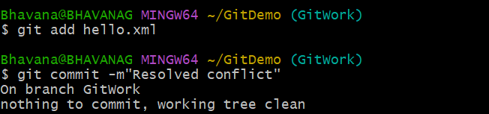

Commit after resolving conflict
- git add hello.xml
git commit -m "Resolved merge conflict in hello.xml"
